

Higher Technological Institute

10th Of Ramadan City

Higher Technological

Institute

Mechanical Department (Mechatronics)

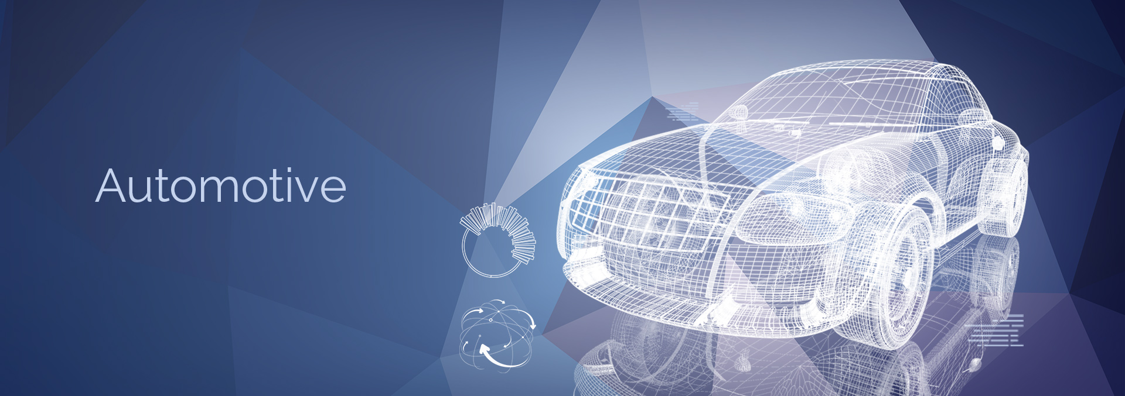

Submitted by:

**Donia Khaled Amer 20160368**

Submitted to:

**Dr. Ahmed Shaaban**

July 2021

**Fourth Training – Proton House**

“This report discusses almost everything about vehicles mechanics, some controlling systems and how to service a car “.

Submitted by:

**Donia Khaled Amer 20160368 [FTR 261]**

Submitted to:

**Dr. Ahmed Shaaban**

July 2021

ACKNOWLEDGMENT

All Thanks to Proton House staff for doing their best to make the information easy to us and explaining everything in the car.

I wish to express my sincere gratitude to Eng. Ibrahim for his continuous help, faithful advice, encouragement and his personal supervision on this work.

ABSTRACT

The report presents all about the car engine how it works, kinds and parts, the engine has many parts and each one of them got its own role, we will discuss each one with its role and all the systems related to the engine

Table of Contents

**Chapter 1 Kinds of Engine** 1

**1.1 what is engine?** 1

**1.3 Engine layout** 2

**1.4 How engine works?** 3

**Chapter 2 Engine parts** 4

**2.1 Cylinder block** 4

**2.2 Piston** 4

**2.3 Piston ring** 5

**2.4 Connecting rod** 6

**2.5 crankshaft** 6

**2.6 Journal bearing** 7

**2.7 Cylinder head** 7

**2.8 Cam and Camshaft** 8

**2.9 Driving camshaft** 9

**2.10 Intake & Exhaust valves** 9

**Chapter 3 Intake and exhaust systems** 10

**3.1 intake system** 10

**3.2 Exhaust system** 12

**Chapter 4 Cooling and lubrication systems** 14

**4.1 Water Cooling System** 14

**4.2 Oil Cooling and Lubrication** 15

**Chapter 5 Fuel systems and Ignition** 18

**5.1 Fuel Supplying System** 18

**5.1.1 Components** 18

**5.1.2 Fuel feeding** 18

**5.2 Ignition System** 20

**5.2.1 Point type Ignition** 21

**5.2.2 electronic ignition** 22

**5.2.3 Distributor less Ignition System (DIS)** 24

**Chapter 6 Breaking Systems** 26

**6.1 Components** 26

**6.2 Brake control system** 28

**6.3 Hand brake** 28

List of Figures

Figure 1: V-shaped Engine 1

Figure 2 Boxer and Inline engines 1

Figure 3 Four stroke engine cycle 3

Figure 4 Cylinder block 4

Figure 5 Water Jacket 4

Figure 6 piston 4

Figure 7 Piston Ring 5

Figure 8: Radiator 15

Figure 9: Thermostat Valve 15

Figure 10: Oil pump 16

Figure 11: Oil Filter 17

Figure 12: Fuel Supplying System 18

Figure 13: Mechanical Fuel Injector 18

Figure 14: Electrical Fuel Injectors 19

Figure 15: Ignition System 20

Figure 16: Disc brake 25

Figure 17: Drum brake 25

Figure 18: Brake pads 26

Figure 19: Speed Sensor 27

Figure 20: ECU 27

Figure 21: Hand Brake System 27

Figure 22: Control Arms 28

Figure 23: Tie rod 28

Figure 24: Stabilizer 28

Figure 25: Stabilizer bar link 29

Figure 26: Ball joint 29

Figure 27: Suspension bushing 29

Figure 28: Shock Absorber 29

Figure 29: Coil Spring 30

Figure 30: Steering Knuckle 30

Figure 31: Constant Velocity shaft 30

Figure 32: Motor mount 30

# **Chapter 1 Kinds of Engine**

## **1.1 what is engine?**

The engine is the devices driving something by changing the energy in the natural source such as fire, wind or electric material to the mechanical energy Therefore, we can define the gasoline engine, as a kind of combustion device in other word, the device changing the heat acquired by combusting the gasoline to the mechanical force for driving the vehicles.

**1.2 Kinds of engine** There are many kinds of the engines.

* 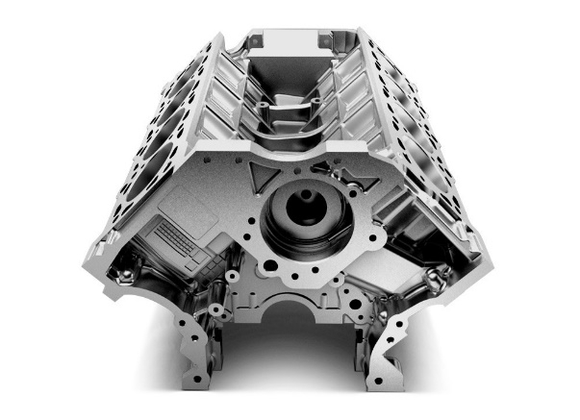The engines can be classified by the number of cylinders, the array style of the cylinder or the equipped method at the vehicle, and so on.

As you know, the engine makes the driving force by the reciprocal movement of the piston in the cylinder so that the power is decided by the number of the cylinder.

Figure : V-shaped Engine

Therefore, the engine is mainly classified by the number of the cylinder. The commercial vehicles are classified into the 2, 3, 4, 6, 8, 12 and 16 cylinders. More displacement volume has the more cylinders.

* According to the array of the cylinder, there are three types including the In-line type with serial arraying of the cylinder, the V type with V-shaped arraying of the cylinder and the Boxer type in which the cylinders are arrayed facing each other.

Figure Boxer and Inline engines

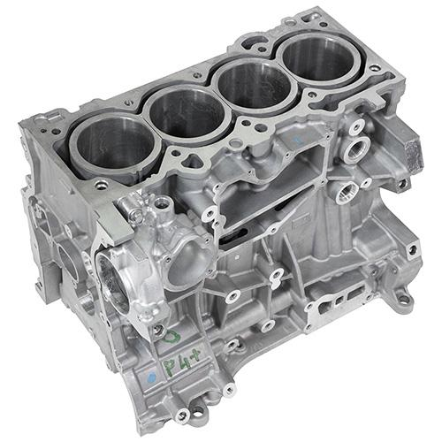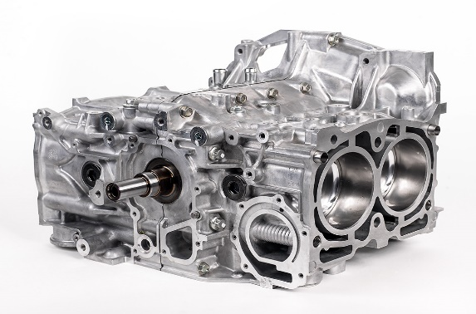

* According to the engine installation type, there are two types; the one is the lengthwise type and the breadthwise type. When the engines are arrayed in length direction of the vehicle is called as the lengthwise type, when the engines are arrayed in width direction of the vehicle is called as the breadthwise type.

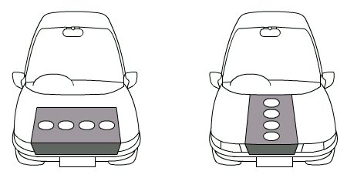

Lengthwise type Breadthwise type

## **1.3 Engine layout**

004

FF: Front Engine Front Drive

FR: Front Engine Rear Drive

MR: Midship Engine Rear Drive

RR: Rear Engine Rear Drive

## **1.4 How engine works?**

The piston completes four separate strokes while turning the crankshaft. A stroke refers to the full travel of the piston along the cylinder, in either direction. The four separate strokes are termed:

1. **Intake:** This stroke of the piston begins at top dead center (T.D.C.) and ends at bottom dead center (B.D.C.). In this stroke the intake valve must be in the open position while the piston pulls an air-fuel mixture into the cylinder by producing vacuum pressure into the cylinder through its downward motion.
2. **Compression:** This stroke begins at B.D.C, or just at the end of the suction stroke, and ends at T.D.C. In this stroke the piston compresses the air-fuel mixture in preparation for ignition during the power stroke. Both the intake and exhaust valves are closed during this stage.
3. **Power (Combustion):** This is the start of the second revolution of the four-stroke cycle. At this point the crankshaft has completed a full 360-degree revolution. While the piston is at T.D.C. (the end of the compression stroke) the compressed air-fuel mixture is ignited by a [spark plug](https://en.wikipedia.org/wiki/Spark_plug) (in a gasoline engine) or by heat generated by high compression (diesel engines), forcefully returning the piston to B.D.C. This stroke produces mechanical work from the engine to turn the crankshaft.
4. 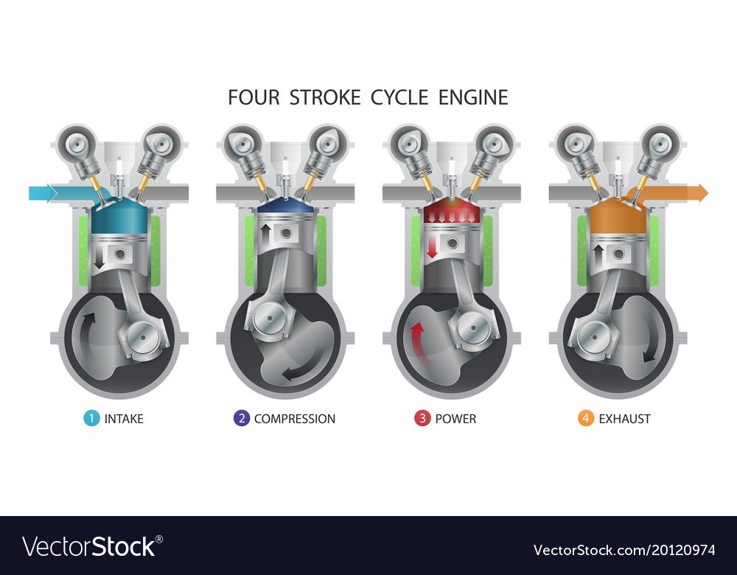**Exhaust:** During the exhaust stroke, the piston once again returns from B.D.C. to T.D.C. while the exhaust valve is open. This action expels the spent air-fuel mixture through the exhaust valve.

Figure Four stroke engine cycle

# **Chapter 2 Engine parts**

## **2.1 Cylinder block**

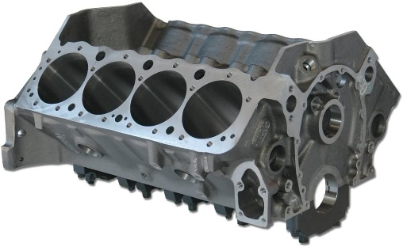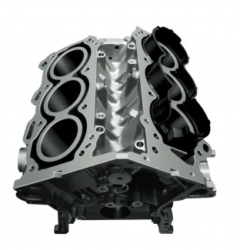 The cylinder block is the basic part of the engine. It is made of cast iron or aluminum. It comprises of the cylinder in which the piston shall be moving reciprocally, the water jacket for circulating the cooling water maintaining the temperature of the cylinder, and the crankshaft installed underneath. For the passenger’s car, the weight of the engine is about 10∼15% of the total weight of the car.

Figure Cylinder block

Figure Water Jacket

**Water jacket:** In side of the block, there should be the water jacket for circulating the cooling water so it should be precisely manufactured for the complicate structure. To prevent from cracking at the bottle neck point of different thickness or to enhance the resistance against wear.

## **2.2 Piston**

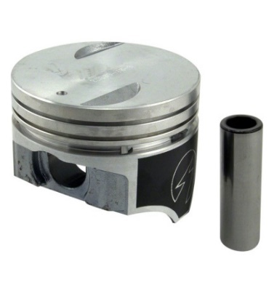The piston moving inside the cylinder reciprocally transmits the weight force according to the combustion of the fuel mixture gas having over temperature of 2000℃ at the combustion stroke to the connecting rod. The first thing to be considered in design of the piston is that the piston should be made of light materials to reduce the inertia force of the reciprocal movement. The next point is that its material should have the strength enough to endure the combustion force. And then, the material of the piston shall have the good heat-trance and not be distorted or deformed by the high temperature. At first, the aluminum or aluminum alloy can be considered for lightening and strengthening. Then, for enhancing the heat resistance to prevent from changing in dimension, the heat treatment shall be performed.

Figure piston

The piston is connected with the connecting rod by a piston pin. So, the most forces of combustion are applied to this pin. As the piston pin is the shape of hollow cylindrical structure.

## **2.3 Piston ring**

Generally, the piston ring comprises of three rings. The two rings near to the piston head are called the compression rings, and the one ring near to the skirt is the oil ring.

* 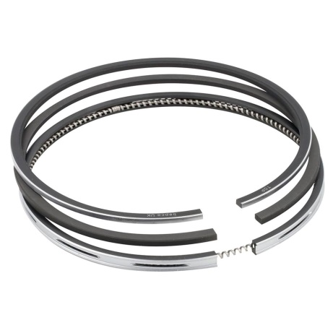**Compression Rings or Pressure Rings**: The compression rings provide sealing above the piston and prevent the gas leakage from the combustion side. The compression rings are located in the first grooves of the piston. The primary function of these rings is to seal the combustion gases and transfer heat from the piston to the piston walls

Figure Piston Ring

* **Wiper ring:** The wiper ring, also called as Napier ring, or backup compression ring, are installed below the compression ring. Their main function is to clean the liner surface off the excess oil and to act as support back up ring on stopping any gas leakage further down which escaped the top compression ring.
* **Oil Control / Scrapper Rings:** The oil control rings control the amount of lubricating oil passing up or down the cylinder walls. These rings are also used to spread the oil evenly around the circumference of the liner. The oil is splashed onto the cylinder walls. These rings are also called scraper rings as they scrap the oil off the cylinder walls and send back to the crankcase. These rings do not allow oil to pass from the space between the face of the ring and the cylinder. Two-piece oil control rings consist of a cast iron or profiled steel ring and a coil spring which is made from heat-resistant spring steel to act around the whole ring circumference for maintaining the pressure and contact.

## **2.4 Connecting rod**

Figure Connecting Rod

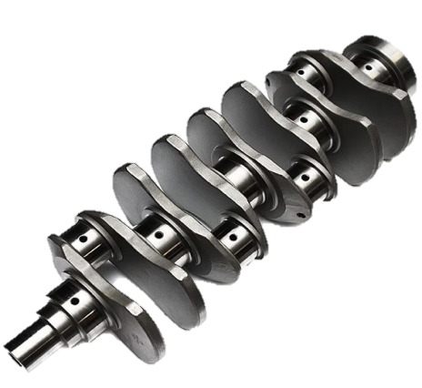A connecting rod is an engine component that transfers motion from the piston to the crankshaft and functions as a lever arm. Connecting rods are commonly made from cast aluminum alloy and are designed to withstand dynamic stresses from combustion and piston movement. The small end of the connecting rod connects to the piston with a piston pin. The piston pin, or wrist pin, provides a pivot point between the piston and connecting rod. Spring clips, or piston pin locks, are used to hold the piston pin in place. The big end of the connecting rod connects to the crankpin journal to provide a pivot point on the crankshaft. Connecting rods are produces as one piece or two-piece components. A rod cap is the removable section of a two-piece connecting rod that provides a bearing surface for the crankpin journal.

## **2.5 crankshaft**

transfer from the reciprocal movement to the rotational movement the crankshaft connects the cranks of each cylinder. The main shaft is called the crank journal and the attaching part to the big end of the connecting rod with the crank is called the crank pin. The connector connecting the crank journal and the crank pin is called the crank arm. The sector formed pendulum at the front of the crank arm is called the counter weight or the balancing weight. The counter weight balances the weights force between the reciprocal movement of the piston and the rotational movement of the crankshaft. Simply think, to balance the weight is to match the inertia forces from the piston and the counter weight as the ratio of 1:1. The counter weight should be small as possible within the requirement load range of the journal in order to reduce the weight of the crankshaft.

Figure Crankshaft

## **2.6 Journal bearing**

The bearing is for helping the smooth rotation of the rotating axis and supporting the rotation axis for the crankshaft of the engine, the plain bearing is more used as the plain bearing is also called as a sliding bearing, the shaft is sliding on the bearing with the lubricant oil. The lubricant oil inserting between the plain bearing and the axis can make the rough surface of these two solid bodies to be smoothly. The two solid bodies are not contacted directly even they are so closed the bearing is made by welding the bearing alloy having light weight and good fatigue resistance such as the copper or aluminum. The bearing has the oil hole and oil groove for supply the lubricant oil to lubricate the contact portion between the connecting rod and the crank pin and between the crankshaft and the crankcase.

Figure Journal Bearing

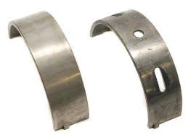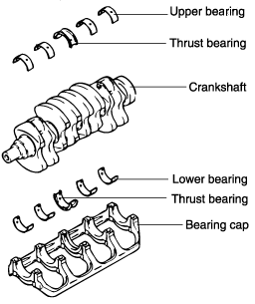

## **2.7 Cylinder head**

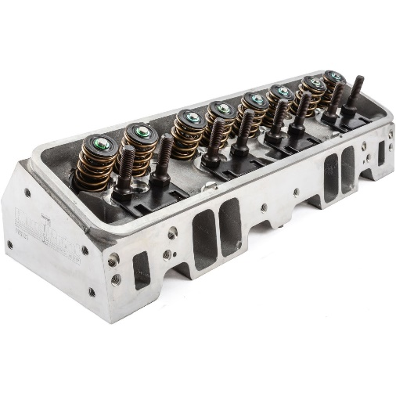The cylinder head is attached on the cylinder block with being inserting a gasket to prevent from leaking the combusted gas. The bottom of the cylinder head is also the roof of the combustion chamber. Therefore, the shape of the cylinder head is very complicated. The rectangular box shaped portion located upper position has the valve driving system inhalation the mixture of fuel to the engine and exhausting the combusted gas, and the ignition plug so that the shape and operation of this part can decide the engine performance such as the combustion of the mixture of fuel.

Figure cylinder head

The combustion chamber is very important part to decide the engine performance. So the shape and the size are the important factors. If the combustion chamber is big, the time interval for combusting the mixture of fuel is long even the mixture can be compressed enough. So the bigger power cannot be ensured. Therefore, it is preferring for the sized of the combustion chamber to be compact.

The intake port is also important part because that the flow of the mixture is defined by the size and the shape of it. Considering just about the flow, the smoother inner surface is better for reducing the resistance against the flow and the straight shape of port is the better. However, the shape of the port is helpful for the inhaling mixture into the cylinder to be form the swirled flow in order to be combusted at the combustion stroke as well as possible.

The water jacket will absorb the remained heat after the combustion until finishing the exhaust stroke as fast as possible to prevent from increasing the temperature of the next inhalation mixtures. Especially, the around portions having the high possibility of increasing the temperature such as the exhaust valve and spark plug should be cooled mainly to prevent from making a trouble by the over heat.

At the cylinder head, there is bearing for supporting the valve driving system including the cam shaft. The bearing is lubricated and cooled by the engine oil.

## **2.8 Cam and Camshaft**

Figure Camshaft

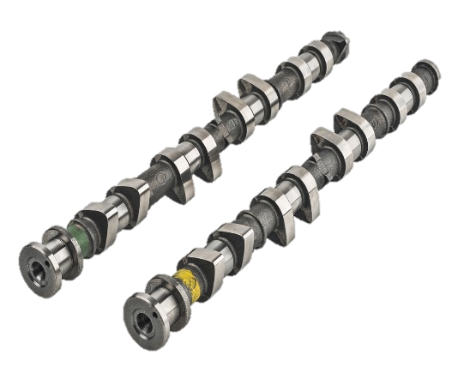 The cam drives the valves operation opening and closing the intake port for inhaling the mixture of fuel into the combustion chamber and the exhaust port for taking out the combusted gas. For the SOHC or DOHC engine, the cam is attached at the camshaft installed at the middle part of the cylinder head. The camshaft has the cams with the same number of the valves for intake and exhaust which are arranged with angles according to the timing of the opening and closing. For the 4-cycle engine, the opening ratio of the intake and exhaust valves is one about the two revolutions of the crankshaft. Therefore, the camshaft revolves with the ratio of one turn about the two revolutions of the crankshaft the extrusion portion of the cam is called as 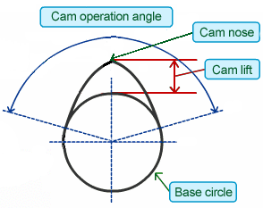the **cam nose** or the **cam robe**. The height is called **cam lift**. The “lift” means that the cams lift the valve so that the opening status is determined by the **cam profile**. The opening and closing timing of the valves are determined by the **operation angle**, 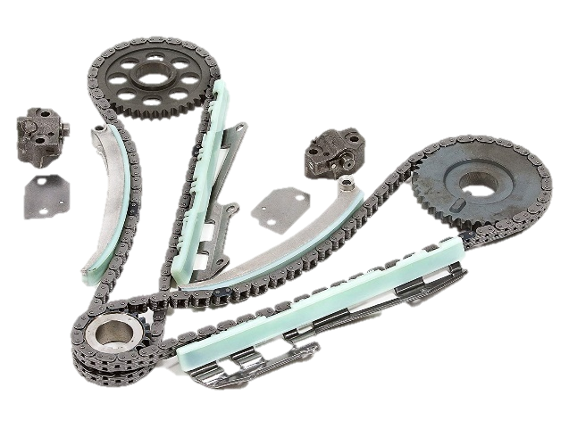the angle from the start point to the end point of the nose.

Figure Cam profile

## **2.9 Driving camshaft**

Is a part of an [internal combustion engine](https://en.wikipedia.org/wiki/Internal_combustion_engine) that synchronizes the rotation of the [crankshaft](https://en.wikipedia.org/wiki/Crankshaft) and the [camshaft](https://en.wikipedia.org/wiki/Camshaft)(s) so that the engine's [valves](https://en.wikipedia.org/wiki/Poppet_valve) open and close at the proper times during each cylinder's intake and exhaust [strokes](https://en.wikipedia.org/wiki/Stroke_(engine)). In an [interference engine](https://en.wikipedia.org/wiki/Interference_engine) the timing belt or chain is also critical to preventing the [piston](https://en.wikipedia.org/wiki/Piston) from striking the valves. Even though the OHC engine can accept the long chain to drive the camshaft, the belt driving method is mainly used. The reason is that the long chain can make mismatching the timing and big noises, and the chain system needs the lubricating equipment. However, the belt is made of fiber and rubber so it can be easily broken by the heat or oil. It is preferring that it should be exchanged at every 90,000km running.

Figure Driving camshaft

## **2.10 Intake & Exhaust valves**

Figure Valves

The cylinder head includes the intake port inhaling the mixture of fuel to the cylinder and the exhaust port taking out the burnt gas. The valves at the ports are the intake valve and the exhaust valve, respectively. According to the valve shape of mushroom, we call poppet valve. The poppet valves consist of the valve head and the valve stem. The valve stem supports the valve guide and the valve spring. The valve is opened by the pressing operation of the cam nose, and closed by the elastic force of the valve spring.

# **Chapter 3 Intake and exhaust systems**

## **3.1 intake system**

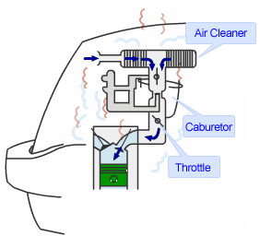The intake system takes the air to mix with the gasoline and inhales the mixtures into the cylinder. Generally, the intake system comprises the air cleaner filtering the dust in the inhaled air, the carburetor mixing the air and the gasoline, and the intake manifold (or inlet manifold) inhaling the mixture into the cylinder, at the head portion of the cylinder.

Figure Carburetor system

Nowadays, the electrical controlled unit for fuel injecting to the intake manifold directly is widely used, so the design of the intake system is changed very much Carburetor intake system

* 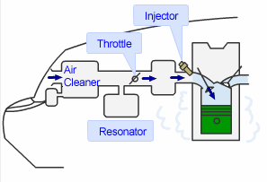At first, the air inlet port which was near the cylinder head is moved to the front grill to intake the ambient air having lower temperature than the air around the engine room.
* As being low temperature air, the air has high density, therefore, the much amount of oxygen will be contained into the inlet air. With the same volume of the inlet air, the lower temperature of the air is the more prefer

Figure MPI intake system

🡪 A modern car air intake system has three main parts:  
 1- Air filter, 2- mass flow sensor, 3- throttle body.

**1-Air Filter**

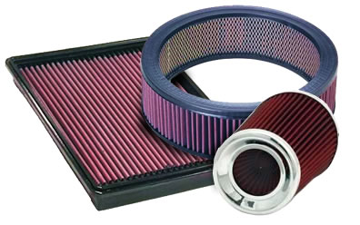An air filter is an important part of a car's intake system, because it is through the air filter that the engine 'breathes'. It is usually a plastic or metal box in which the air filter sits. The air filter's job is to filter out dirt and other foreign particles in the air, preventing them from entering the system and possibly damaging the engine.

Figure 19: Filters

**2-Mass flow sensor**

A mass air flow sensor is used to find out the mass of air entering a fuel-injected internal combustion engine. From mass flow sensor, then, does it go to the throttle body. There are two common types of mass airflow sensors in use on automotive engines. They are the vane meter and the hot wire.

**3-Throttle Body**

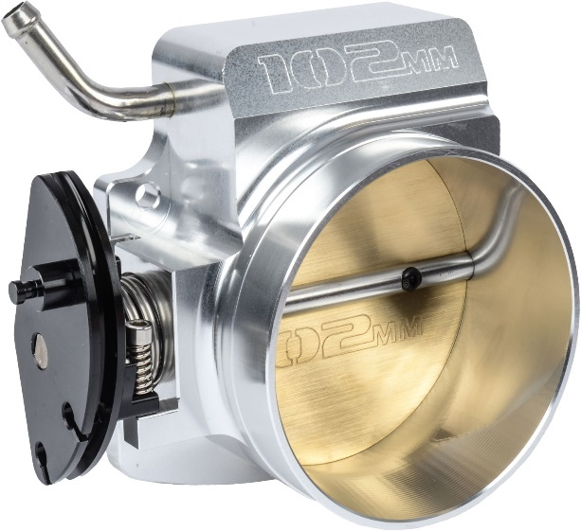The throttle body is the part of the air intake system that controls the amount of air flowing into an engine's combustion chamber. When the accelerator is depressed, the throttle plate opens and allows air into the engine. When the accelerator is released, the throttle plate closes and effectively chokes-off air flow into the combustion chamber. This process effectively controls the rate of combustion and ultimately the speed of the vehicle. The throttle body is usually located between the air filter box and the intake manifold, and it is usually located near the mass airflow sensor.

Figure 20: Throttle Body

The resonance chamber is a small box branched from the duct as the device for reducing the intake noise, and it is called as the regenerator chamber or the side branch

## **3.2 Exhaust system**

By opening exhaust port of the cylinder head, the combusted gas is exhausted through the exhaust manifold, the exhaust pipe gathering the combusted gas from each cylinder, the catalyst converter purifying the used gas and the silencer (muffler) reducing combustion noise. The exhaust manifold is made of the casting iron having high heat resistance, or the aluminum alloy. Also, the exhaust gas temperature is high. So, it is need to make the exhaust system with the material having better heat resistance

* 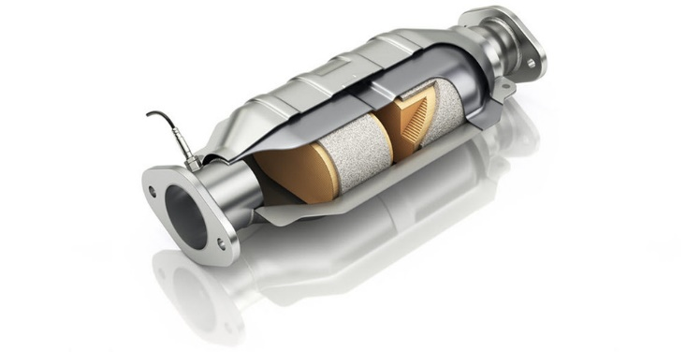The catalyst converter is used for purification of the exhausted gases. There is a manifold catalyst installed near the manifold and a under catalyst installed under the floor. The manifold catalyst is more effective because the exhaust temperature is higher than the other system. However, it can be easily aged by the high temperature so usually two pieces are used. The under catalyst is not easily degraded, however it has high performance of purification.

Figure 21: Catalyst

* 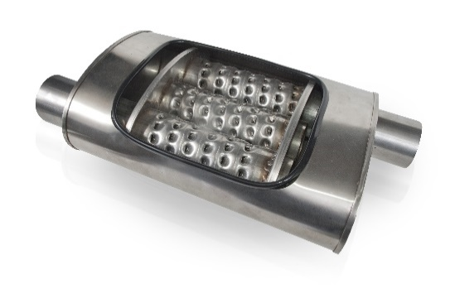The muffler is equipped for reducing the temperature and pressure of the exhausted gas as well as the combustion and exhausting sound.

If the fuel is combusted perfectly, then any harmful material is not included in the exhaust gases. The fuel, gasoline, consists of hydrocarbon, the compound of the carbon and the hydrogen. In the chamber, the fuel is changed into the carbon dioxide (CO2) and water (H2O) with making heat energy.

Figure 22: Muffler

Among the gases generated during this complicated reaction, the carbon monoxide, hydrocarbon gas and the nitrogen oxide are the major harmful materials.

**Harmful Gases**

**1- The carbon monoxide (CO)**: is the unstable material having one carbon and one oxygen so that it can be easily changed into the carbon dioxide, the stable and harmless material, if additional oxygen and heat are supplied. If we breath the carbon monoxide, then it will catch the oxygen delivered by the hemoglobin in the blood to be carbon dioxide, more stable material. So, our body is lag of oxygen.

**2- The hydrocarbon gas:** is come from the fuel not combusted or the intermediated material during the chemical process of combustion. It is come from the blow by gas or the vaporized fuel from the fuel tank.

If this gas is revealed at the atmosphere, then it will react with the oxygen and hydrogen and change into the aldehyde, the harmful material having strong stimulus.

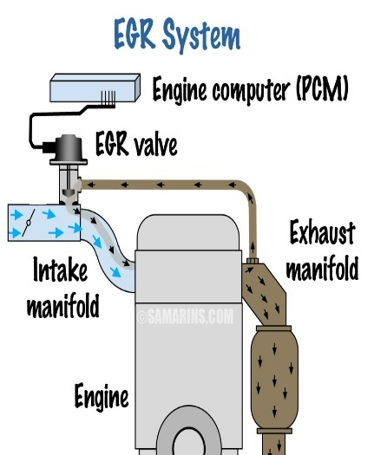 **3- The nitrogen oxide (NOx)** is come from the reaction between the nitrogen (78% of the air) and the oxygen in the air by the high temperature of 2000℃ in the chamber. As the nitrogen oxide is made by the difference mechanism with the carbon monoxide or hydrocarbon gas, it will be increased when the carbon monoxide and hydrocarbon are reduced by almost perfect combustion. When the combustion temperature is low, the nitrogen oxide will be less; however, the combustion efficiency will be worse. So, the nitrogen oxide shall be treated at the exhaust system.

**🡪The Exhaust Gas Recirculation device** is called as EGR as an abbreviation. It is the device for returning some amount of the exhaust gas back to the cylinder. Doing so, the actual amount of fuel is reduced and the combustion speed is slow, and then the maximum temperature of the combusting chamber will be lowered and the amount of the nitrogen oxide will be also reduced. But, if the amount of the re-circulated exhaust gas is too much, then the engine output and fuel efficiency will be worse, so it is important to control the amount of EGR.

Figure 23: EGR System

# **Chapter 4 Cooling and lubrication systems**

## **4.1 Water Cooling System**

* A system, which controls the engine temperature, is known as a cooling system. The cooling system is provided in the IC engine for the following reasons:
* The temperature of the burning gases in the engine cylinder reaches up to 1500 to 2000°C, which is above the melting point of the material of the cylinder body and head of the engine. Therefore, if the heat is not dissipated, it would result in the failure of the cylinder material.
* Due to overheating, large temperature differences may lead to a distortion of the engine components due to the thermal stresses set up. This makes it necessary for, the temperature variation to be kept to a minimum.
* It serves two purposes in the working of an engine:
* It takes away the excessive heat generated in the engine and saves it from overheating.
* It keeps the engine at working temperature for efficient and economical working.
* The water flows from the lower portion of the radiator to the water jacket of the engine through the centrifugal pump. After the circulation water comes back to the radiator, it loses its heat by the process of radiation.

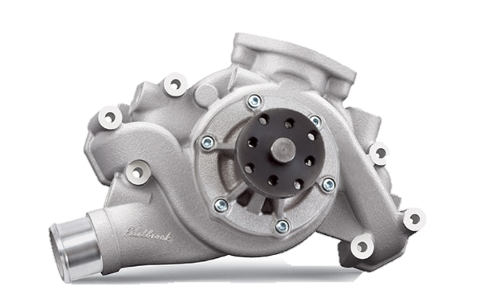Water Cooling Components

1. **Water pump:** This is a centrifugal type pump. It is centrally mounted at the front of the cylinder block and is usually driven by means of a belt. The bottom of the radiator is connected to the suction side of the pump. The power is transmitted to the pump spindle from a pulley mounted at the end of the crankshaft. Seals of various designs are incorporated in the pump to prevent loss of coolant from the system.

Figure 24: Water Pump

1. **Fan:** It serves two purposes in the cooling system of an engine. First it draws atmospheric air through the radiator and thus increases the efficiency of the radiator in cooling hot water. Second It throws fresh air over the outer surface of the engine, which takes away the heat conducted by the engine parts and thus increases the efficiency of the entire cooling system.
2. 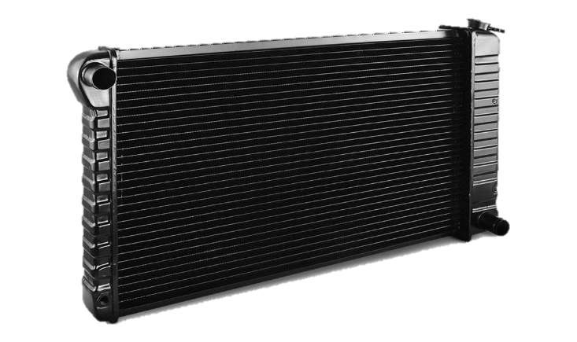**Radiator:** The purpose of the radiator is to cool down the water received from the engine. The radiator consists of three main parts: (i) upper tank, (ii) lower tank and (iii) tubes. Hot water from the upper tank, which comes from the engine, flows downwards through the tubes. The heat contained in the hot water is conducted to the copper fins provided around the tubes.

Figure : Radiator

1. 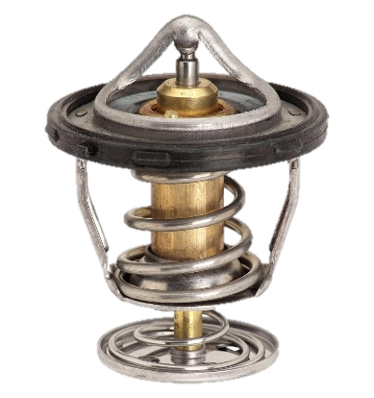**Thermostat Valve:** It is a kind of check valve which opens and closes with the effect of temperature. It is fitted in the water outlet of the engine. During the warm-up period, the thermostat is closed and the water pump circulates the water only throughout the cylinder block and cylinder head. When the normal operating temperature is reached, the thermostat valve opens and allows hot water to flow towards the radiator. Standard thermostats are designed to start opening at 70 to 75°C and they fully open at 82°C. High temperature thermostats, with permanent anti-freeze solutions tart opening at 80 to 90°C and fully open at 92°C.

Figure : Thermostat Valve

## **4.2 Oil Cooling and Lubrication**

* Engines are made of many moving parts. Due to continuous movement of two metallic surfaces over each other, there is wearing moving parts, generation of heat and loss of power in the engine lubrication of moving parts is essential to prevent all these harmful effects.

PURPOSE OF LUBRICATION

1. **Reducing frictional effect:** The primary purpose of the lubrication is to reduce friction and wear between two rubbing surfaces. Two rubbing surfaces always produce friction. The continuous friction produce heat which causes wearing of parts and loss of power. In order to avoid friction, the contact of two sliding surfaces must be reduced as far as possible. This can be done by proper lubrication only. Lubrication forms an oil film between two moving surfaces. Lubrication also reduces noise produced by the movement of two metal surfaces over each other.
2. **Cooling effect:** The heat, generated by piston, cylinder, and bearings is removed by lubrication to a great extent. Lubrication creates cooling effect on the engine parts.
3. **Sealing effect:** The lubricant enters into the gap between the cylinder liner, piston and piston rings. Thus, it prevents leakage of gases from the engine cylinder.
4. **Cleaning effect:** Lubrication keeps the engine clean by removing dirt or carbon from inside of the engine along with the oil.

LUBRICATION SYSTEM

* The lubricating system of an engine is an arrangement of mechanism and devices which maintains supply of lubricating oil to the rubbing surface of an engine at correct pressure and temperature. And there are many ways to the parts to be lubricant like crankshaft (It is always immersed in the oil) but the piston and the connecting rod are fed with oil pumping directly to them by special paths.

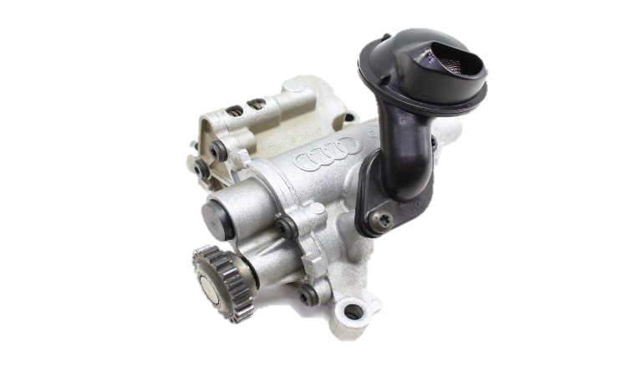

Lubrication components

1. **Oil pump:** Oil pump is usually a gear type pump, used to force oil into the oil pipe. The pump is driven by the camshaft. The lower end of the pump extends down into the crankcase which is covered with a screen to check foreign particles. A portion of the oil forced to the oil filter and the remaining oil goes to lubricate various part of the engine.

Figure : Oil pump

1. 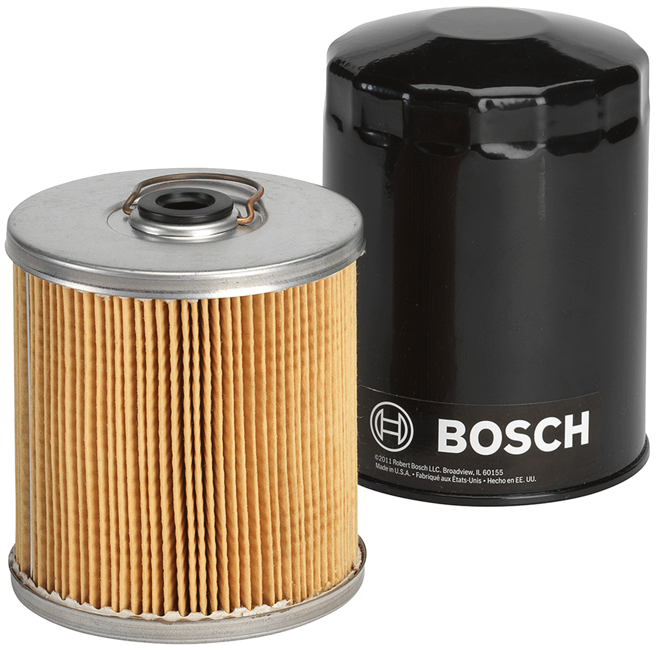**Oil filter:** Lubricating oil in an engine becomes contaminated with various materials such as dirt, metal particles and carbon. Oil filler removes the dirty elements of the oil in an effective way. Some oil filter can be cleaned by washing, but in general old filters are replaced by new filters at specified interval of time prescribed by manufacturers.

Figure : Oil Filter

1. **Oil gauge:** Oil pressure gauge is used to indicate the oil pressure in the oil lines. It serves to warn the operator of any irregularity in the system.
2. 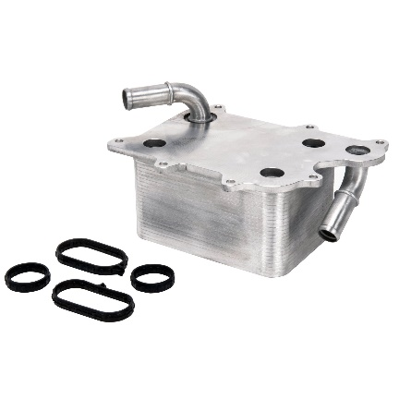**Oil Cooler:** The oil cooler receives the lubricant’s heat and exchanges it with the ambient air or the radiator coolant. It consists of two pipes inside it, one of them for the oil and another one for water and the two pipes almost touch each other to help in heat transfer process.

# **Chapter 5 Fuel systems and Ignition**

## **fuel sys5.1 Fuel Supplying System**

The gasoline, the fuel, is contained in the fuel tank and sent to the fuel injection device after eliminating dust and water by filter.

### **5.1.1 Components**

**1- The fuel tank:** is made of galvanized steel to prevent rust, as well as the plastic tank is more used. To protect the fuel from leaning one side, there are some partitions, called **separator**, and level gauge is attached.

Figure : Fuel Supplying System

**2- The fuel pump:** has various types. The carburetor uses mechanical pump, ECM system uses electrical pump using electric motor mostly.

**3- Regulator:** pressure controller, is attached for sending the gasoline to the injector after controlling the gasoline pressure within the specific range.

### **5.1.2 Fuel injecting**

* **Mechanical Fuel Injecting Device**

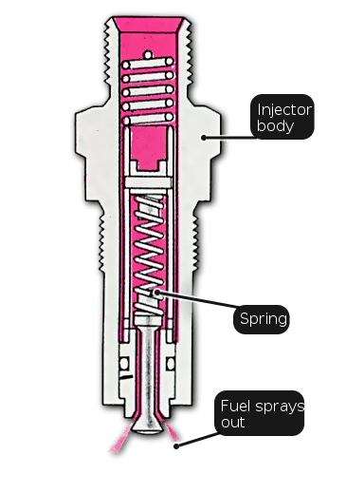Basically, as regarding the negative pressure as the air amount injected, the carburetor supplies proper amount of gasoline using only mechanical device. Therefore, it cannot maintain the air-fuel ratio uniformly. It is need to control the injected fuel amount exactly using the predetermined the air-fuel ratio to prevent from wasting the fuel or to enhance the engine response.

A new system is developed in which the inhaled air amount is measured directly, and the gasoline is sprayed to the intake manifold with the optimized the air-fuel ratio using the mechanical device. This is the K-Jetronic the main feature of the K-Jetronic is that installing a circular plate named sensor plate in front of the throttle valve, the gasoline amount is controlled using that the opening state of this plate is changed by the air amount. When the throttle valve is open, the air presses the sensor plate installing in the air flow meter. The lever supporting this plate is connected to the device for controlling the injected fuel amount, and the gasoline is injected to the fuel injecting device by a response to the plate operating.

Figure : Mechanical Fuel Injector

As a system replacing the carburetor, the K-Jetronic has better reliance. However, it sometimes injects the fuel in the same manner of carburetor and controls the fuel amount mechanically. Therefore, it is hard to control the mixture ratio precisely.

In some cases, by accepting an ECM to a portion of the system, the KE-Jetronic supplementing these week points is developed. However, step by step, the full ECM system is replacing these mechanical systems in order to regulate the exhaust gas and to enhance the fuel efficiency.

* **Electrical Fuel Injection System**

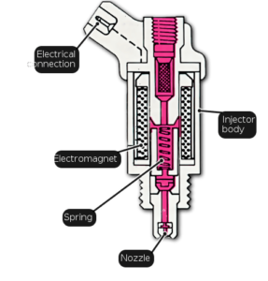The main part of the electrical fuel injecting system is the fuel injecting device deciding the amount of fuel to make proper mixing ratio by measuring the inlet air amount. This system comprises of the device of measuring the air amount, the device of injecting the fuel, and the device of controlling theses operations. the electrical fuel injecting system the measured air amount by the air flow sensor is sent to computer as an electric signal to decide the fuel amount with the result from the sensor for checking the engine status. By these devices, it is possible to control the air-fuel ratio precisely.

Figure : Electrical Fuel Injectors

## **5.2 Ignition System**

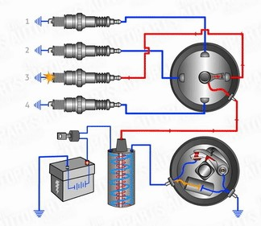 All automotive ignition systems (except diesels) have to generate a spark strong enough to jump across the spark plug's gap. This is accomplished using an ignition coil consisting of two coils of wire wrapped around an iron core. The goal is to create an electromagnet by routing the battery's 12 volts through the primary coil. When the car ignition system turns off the power flow, the magnetic field collapses, and as it does, a secondary coil captures this collapsing magnetic field and converts it into 15,000 to 25,000 volts.

Figure : Ignition System

In order to generate maximum power from the air/fuel mixture, the spark must fire at just the right moment during the compression stroke there are several methods to control spark timing.

### **5.2.1 electronic ignition**

Main Components

**1. Battery**

It is the powerhouse of the ignition system as it supplies the necessary energy to the ignition system. Same as battery coil ignition system.

**2. Ignition Switch**

it is the switch used in ignition system which governs the ON and OFF of the system, same as the battery coil ignition system.

**3. Ignition Control Module or Control Unit of Ignition System**

It is the brain or programmed instruction given to the ignition system which monitors and control the timing and intensity of the spark automatically. It is the device that receives voltage signals from the armature and set the primary coil to ON and OFF, it can be placed separately outside the distributor or can be place in electronic control unit box of the vehicle.

**4. Armature**

Contact breaker points of battery ignition system is replaced by an armature which consists of a reflector with teeth (the rotating part), vacuum advance and a pickup coil(to catch the voltage signals),Electronic module receives the voltage signals from the armature in order to make and break the circuit, which in turn sets the timing of the distributor to accurately distribute current to the spark plugs.

**5. Ignition Coil:** Same as the battery ignition coil system ignition coil is used in electronic ignition system to produce high voltage to the spark plug.

**6. Ignition Distributor:** As the name indicates it is the device use to distribute the current to the spark plugs of the multi cylinder engine.

**7. Spark Plug**

Spark plug is used to generate spark inside the cylinder.

Working of Electronic Ignition System

* When the driver switches ON the ignition switch in order to start a vehicle the current starts flowing from the battery through the ignition switch to the coil primary winding, which in turn starts the armature pickup coil to receives and send the voltage signals from the armature to the ignition module.
* When the tooth of the rotating reflector comes in front of the pickup coil as shown in the fig the voltage signal from pickup coil is sent to the electronic module which in turn senses the signal and stops the current to flow from primary coil.
* When the tooth of the rotating reflector goes away from the pickup coil, the change in voltage signal is sent by pickup coil to the ignition module and a timing circuit inside ignition module turns ON the current flow.
* A magnetic field is generated in the ignition coil due to this continuous make and break of the circuit which induced an EMF in secondary winding which increases the voltage up to 50000 Volts.
* This high voltage is then sent to distributor, which has the rotating rotor and distributor points which is set according to the ignition timing.
* 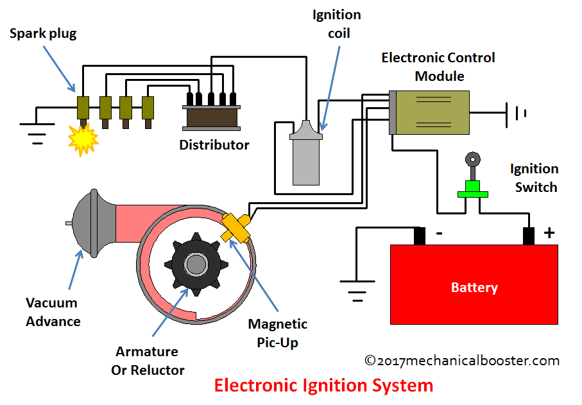When the rotor comes in front of any of those distributor points the jumping of voltage through the air gap from the rotor to the distributor point takes place which is then sent to the adjacent spark plug terminal through the high tension cable and a voltage difference is generated between the central electrode and ground electrode which is responsible for generating a spark at the tip of the spark plug and finally the combustion takes place.

### **5.2.3 Distributor less Ignition System (DIS)**

Is the ignition system in which the distributor of the electronic ignition system is replaced with number of induction coils i.e. one coil per cylinder or one coil for pair of cylinders, and the timing of the spark is controlled by an Ignition control unit (ICU) and the Engine control unit (ECU), which makes this system more efficient and accurate. Due to the use of multiple ignition coils which provides direct voltage to the spark plugs this system is also known as Direct Ignition System (DIS).

Main Components

**1. Battery:** Same as the electronic ignition system, battery is used as the power house for the DIS.

**2. Ignition Switch:** It governs the ON and OFF of the ignition system, same as the electronic ignition system.

**3. Ignition Coils:** Unlike electronic ignition system in which single ignition coil is used to generate high voltage, DIS uses number of ignition coils i.e. each coil per spark plug which generate high voltage individually for each spark plug.

**4. Ignition Control Module (ICM)** or Ignition Control Unit: It is the programmed instruction given to the chipset which is responsible for setting the primary coil circuit to ON or OFF,

**5. Magnetic Triggering Devices:** These are the devices used to control the timing of the spark plug by sensing the position of the crankshaft and camshaft both that are-

**(i) Camshaft Triggering Device:** Mounted on the camshaft and used for sensing valve timing.

**(ii) Crankshaft Triggering Device:** Mounted on the crank shaft and used for sensing the piston position or stroke.

**5. Spark Plug:** It is used to generate spark inside the cylinder.

Working of Distributor less Ignition System

* When the ignition switch is turned ON, the current from the battery stats to flow through the ignition switch to the electric control unit (which keeps on processing data and calculating timing) of the vehicle which is connected to the ignition module and coils assembly, (which makes and breaks the circuit).
* The triggering wheels mounted on the camshaft and crankshaft have equally spaced teethes with one gap, and the position sensors which consists of the magnetic coil that constantly generates magnetic field as the camshaft and crankshaft rotates.
* When these gaps come in front of the positioning sensors, fluctuation in the magnetic field occurs and the signals of both the sensors are sent to the ignition module which in turn senses the signals and the current stops to flow in the primary winding of the coils .and when these gaps go away from the sensors the signals of both the sensors are sent to the ignition module which turns ON the current to flow in the primary winding of the coils.
* 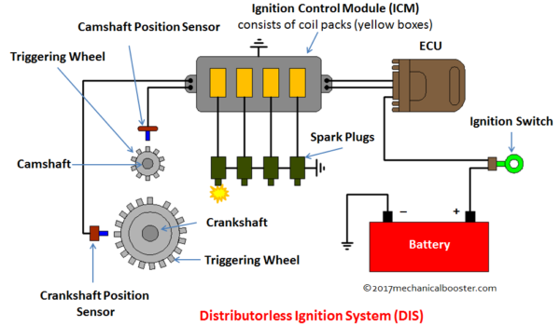This continuous make and break of the signals generate magnetic field in the coils which in turn induced EMF in the secondary winding of the coils and increases the voltage up to 70000 volts.
* This high voltage is then sent to the spark plugs and the generation of sparks takes place.
* The timing of the spark plugs is controlled by electronic control unit by continuously processing the data received from the ignition control module.

# **Chapter 6 Breaking Systems**

* The brake system is the main important safety side in the car to make the car stop and there is no other purpose for it. The brakes are controlled by the driver pressing on the brake pedal. The master cylinder assists in applying pressure to hydraulic fluid in the brake pipes. Pressurized fluid in the brake pipes feeds the brake components at each of the individual wheels. The brakes respond equally (on the same axle) to the pressure to slow the vehicle.

## **6.1 Components**

* **Disc Brake:** A disc brake system consists of a brake disc, a brake caliper and brake pads. When the brake pedal is applied, pressurized hydraulic fluid squeezes the brake pad friction material against the surface of the rotating brake disc. The result of this contact produces friction which enables the vehicle to slow down or stop.
* 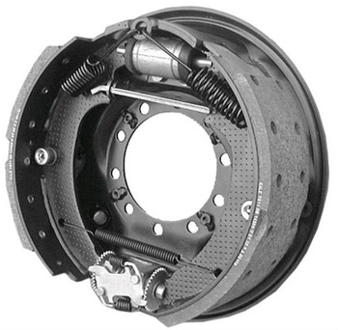**Drum Brake:** A drum brake system consists of hydraulic wheel cylinders, brake shoes and a brake drum. When the brake pedal is applied the two curved brake shoes, which have a friction material lining, are forced by hydraulic wheel cylinders against the inner surface of a rotating brake drum. The result of this contact produces friction which enables the vehicle to slow down or stop.

Figure : Disc brake

Figure : Drum brake

Main Components

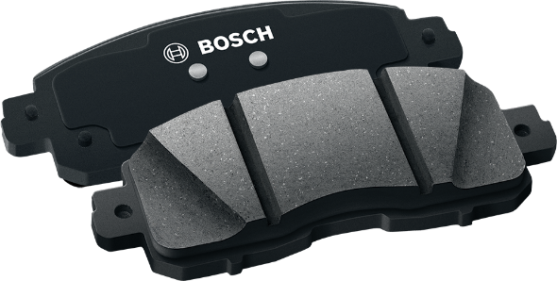**1. Caliper or Piston:** The brake caliper applies pressure to the brake pads by the pistons inside it which creates friction to help to bring the car to a safe stop when you push the brake pedal. While brake calipers can come in different shapes, sizes and even colors. They all perform the same function. Over time, like most car parts, the brake caliper can start to display signs of wear and tear, often caused by frequent on-off braking and general daily use.

**2. Brake Pads:** The brake pads on your car are one of the most important safety features. These relatively small pads work with the brake discs to slow the car down or bring your car to a stop as safely as possible.

Figure : Brake pads

**3. Vacuum pump:** Is main component to give a vacuum to any part in the car need to be controlled specially the gates. But is the most important part in the brake system because it gives more power to the brake.

How the system works?

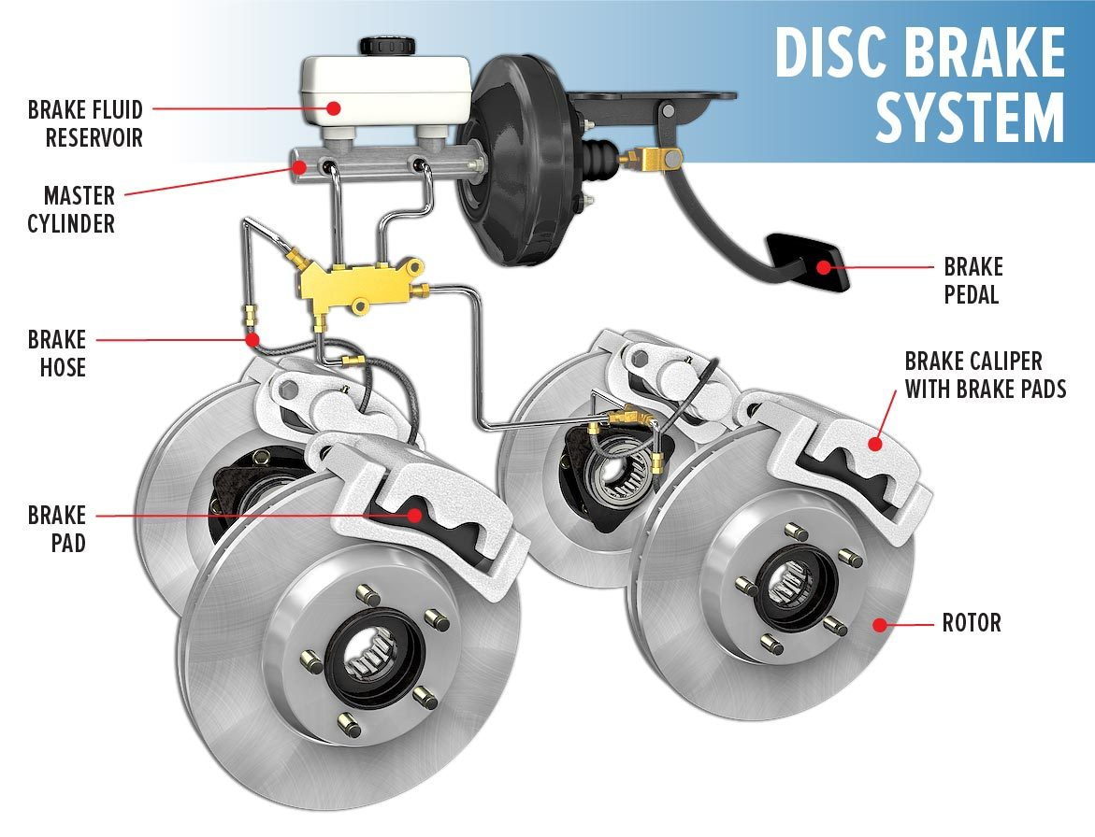When the driver presses on the brake pedal the vacuum helps the servo doubling power to the master which responsible to send the compressed oil to the caliper or to be controlled by many different control systems.

## **6.2 Brake control system**

* **ABS – Anti lock Brake System:**

1. 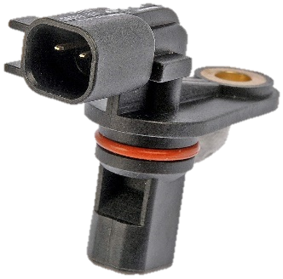**Speed Sensor:** The wheel speed sensor consists of a permanent magnet and coil assembly. It generates electrical pulses when the pole wheel rotates. The rate at which the pulses are generated is a measure of wheel speed.

Figure : Speed Sensor

1. 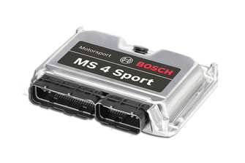**Electronic control unit (ECU):** Wheel speed sensor signal are the input to the Electronic Control Unit. The ECU computers wheel speeds, wheel deceleration and acceleration. If any wheel tends to lock, the ECU actuates the corresponding Modulator valve to prevent wheel lock. The ECU is normally mounted in driver's cabin.

Figure : ECU

1. **Actuator:** The actuator on an anti-lock brake system (ABS) is known as an ABS actuator. This is an electronic device that receives a signal from the vehicle's computer to control the brake pressure so that the wheels will not become locked up.

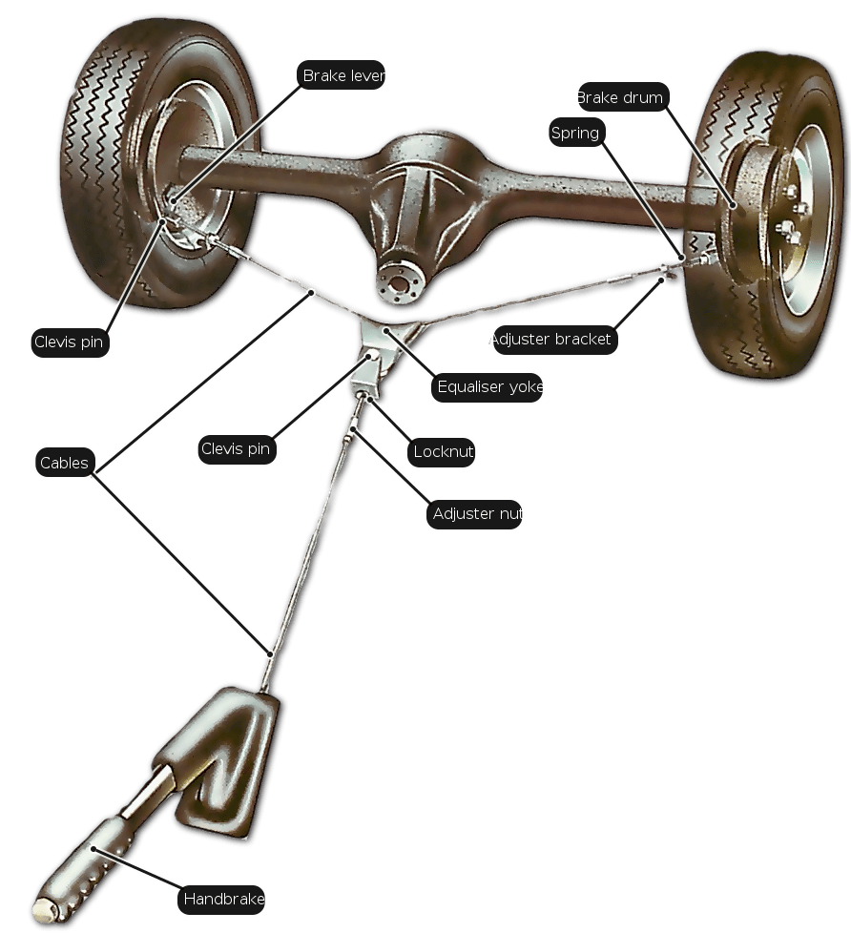

## **6.3 Hand brake**

Hand breaks effect in the rear wheel. A cable/rod links the hand break to the rear-wheel brakes. There is a pressure equalizer and brake adjuster coupling the cable links together. Left and right flexible cables link the operation to the wheels. Pistons of hand brake is located inside the brake disc and open outward to brake.

Figure : Hand Brake System

# **CHAPTER 7 Suspension System & Diagnoses**

Suspension Components

**1. Tie rod:** Tie rod ends are simple parts that connect the steering rack to the steering knuckle on each front wheel. An adjusting sleeve sits between the inner and outer tire rod ends. When you turn the steering wheel, it transmits that movement through various steering components until the tie rod ends push or pull the wheel and make the wheels turn. Having the ability to turn corners is pretty important, so tie rod ends play a large role in any vehicle's safety. Deceptively simple looking, the outer tie rod end hides some internal parts.

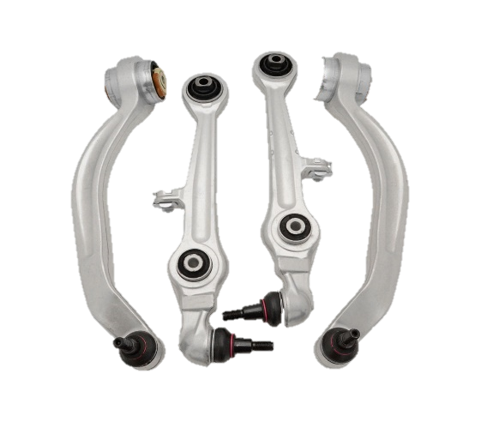

Figure 32: Control Arms

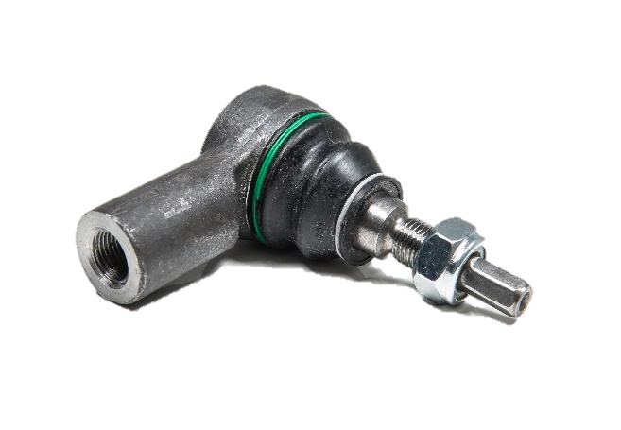

Figure 33: Tie rod

**2. Control** **arms:** is a hinged suspension link between the chassis and the suspension upright or hub that carries the wheel. A control arm may be used to carry the suspension load and transmit them to the spring or shock absorber. There are two angles to be controlled by the control are which are (i) Camper, (ii) Caster.

**3. Sway bar (Stabilizer):** is a part a suspension that helps reduce the body roll of a vehicle during fast cornering or over road irregularities. It connects opposite (left/right) wheels together. A sway bar increases the suspension's roll stiffness. is intended to force each side of the vehicle to lower, or rise, to similar heights.

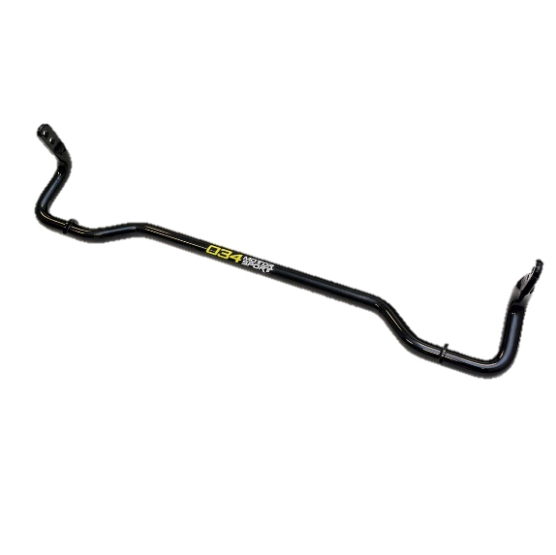

Figure 34: Stabilizer

**4. Stabilizer bar link:** Attach the stabilizer with any suspension part like shock absorber or the control arm and there is a ball join in its two ands to reduce the wearing.

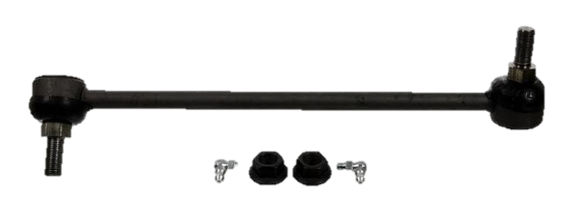

Figure 35: Stabilizer bar link

**5. Ball joint:** ball joints are spherical bearings that connect the control arms to the steering knuckles. They are used on virtually every automobile made and work similarly to the ball-and-socket design of the human hip joint. Ball joints play a critical role in the safe operation of an automobile's steering and suspension.

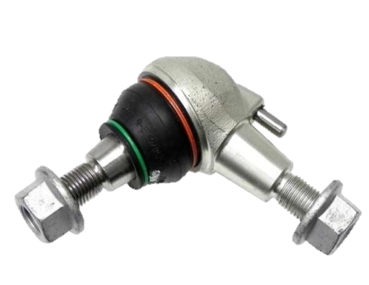

Figure 36: Ball joint

**6. Suspension bushing:** Car bushings are small rubber suspension components that are used to isolate vibration, provide cushioning, and reduce friction between metal parts on your vehicle. The most common car bushings are control arm bushings and sway bar bushings, but you will also find bushings positioned between your vehicle's suspension and frame in several other areas.

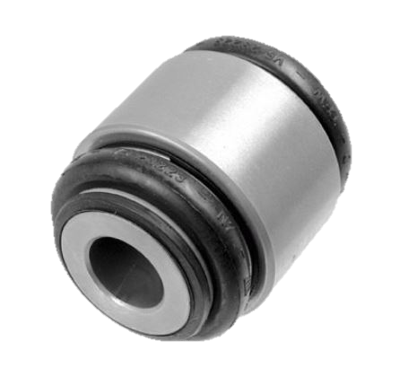

Figure 37: Suspension bushing

**7. Shock absorber:** The shock absorbers of the car play a very important role in the safety and the comfort of the vehicle. shock absorbers are hydraulic (oil) pump like devices that help to control the impact and rebound movement of your vehicle's springs and suspension. Along with smoothening out bumps and vibrations, the key role of the shock absorber is to ensure that the vehicle’s tires remain in contact with the road surface at all times, which ensures the safest control and braking response from your car.

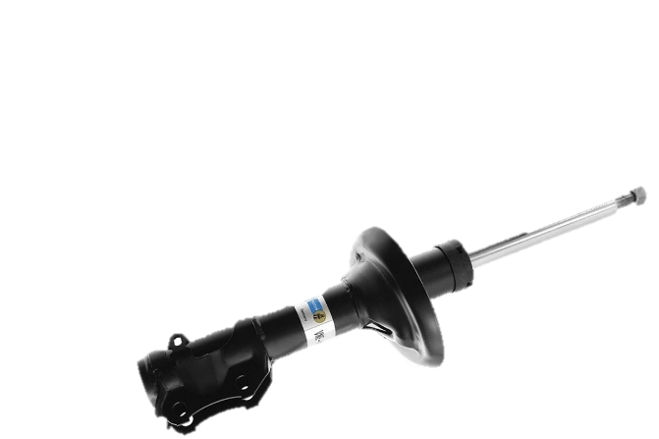

Figure 38: Shock Absorber

**8. Coil spring:** is a mechanical device which is typically used to store energy and subsequently release it, to absorb shock, or to maintain a force between contacting surfaces. And it is the responsible to lift the body of the car.

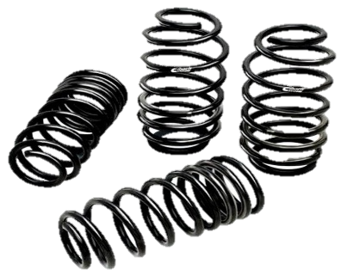

Figure 39: Coil Spring

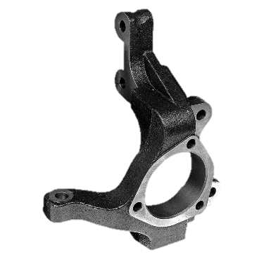

Figure 40: Steering Knuckle

**9. Steering Knuckle:** Is that part which contains the wheel hub or spindle, and attaches to the suspension and steering components. It is variously called a steering knuckle, spindle, upright or hub.

**10. Constant velocity shaft:** Is a mechanical coupling in which the rotational speed of the output shaft is the same as that of the input shaft whatever the operating angle of the joint.

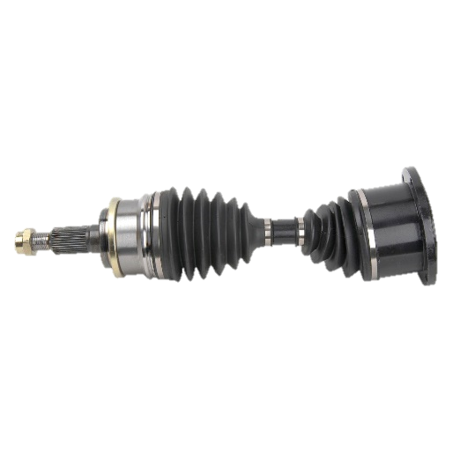

Figure 41: Constant Velocity shaft

**11. Motor mount:** Is the component responsible for securing the engine of a vehicle to the chassis. And it works as an absorber of motor vibrations.

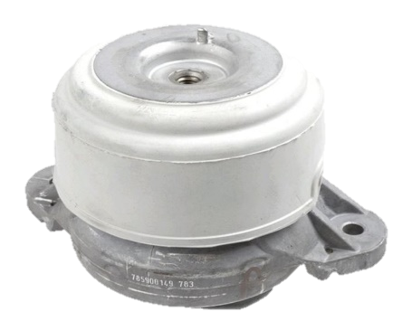

Figure 42: Motor mount

**12. Gearbox mount:** Is the component responsible for securing the gearbox of a vehicle to the chassis. And it works as a vibration absorber.

# **Chapter 7 Servicing and Maintenance**

As said before the servicing and maintenance play a very critical role to keep and raise car’s performance.

How to maintenance a car?

Firstly, you need to know that the car maintenance should be done every 10,000 KM in all cars so almost all new cars send you a message in the car dashboard every 10,000 KM to warn the owner that the maintenance time is coming.

**The services are done as following: -**

1. First step is to connect the OBD port to the car and start the diagnostic software to begin the diagnosis
2. After that if there any problem detected car owner must be told and must give a permission to change or repair the car or not
3. If there nothing found the next step begins which is to check if there any hidden leakage
4. Then check the transmission parts
5. Check the suspension functionality and the wheels angels.
6. The last step is to start changing the following:

* Engine oil
* Gearbox Oil (Depends on Oil Type) (80,000 or 100,000 Km)
* Oil filter
* Air filter
* Brake Oil (100,000 Km)